**Health Data Breaches**

As society embraces technology and transactions conducted through electronic devices become more prevalent, the importance of cybersecurity grows. These transactions often involve sensitive information, such as social security numbers and banking details, making data a highly desirable asset. The focus of this project is on health data breaches that occurred between 2010 and 2016, as reported by the US Department of Health and Human Services Office for Civil Rights. The data is categorized based on the type of breach, such as hacking, improper data disposal, or loss. In some instances, data exposure can be attributed to inadequately trained employees, so the visual representations also indicate whether a business associate (employee) was present during the breach. The objective is to analyze common areas of data loss and devise a plan to prevent such errors in the future, with the ultimate goal of avoiding customer lawsuits.

**Contents**

**Project Overview**

**Problem Statement**

**KPI and Data Dictionary**

**Executive Summary and the problems that occurred during the project.**

**Key Insights**

**Recommendations**

**Deployment**

**Project Overview**

As society's technological proficiency continues to grow and transactions conducted through electronic devices become increasingly common, the demand for cybersecurity becomes more pressing. These transactions often involve valuable data, such as social security numbers and banking information, making data a highly desirable commodity. The focus of this project is to examine health data breaches that occurred between 2010 and 2016, as documented by the US Department of Health and Human Services Office for Civil Rights. The data is categorized based on the type of breach, including hacking, improper data disposal, and loss, among others. It is worth noting that data exposure can sometimes occur due to inadequately trained employees. Therefore, the visuals in this project also indicate whether a business associate (employee) was present at the time of the breach. The objective is to analyze the common areas of data loss and devise a plan to prevent similar mistakes in the future, with the ultimate goal of avoiding customer lawsuits.

**Problem Statement**

Following the outbreak of the Covid-19 pandemic, the United States has experienced an unprecedented surge in hospital visits. Additionally, there has been a significant increase in the number of reported health data breaches in 2016, predominantly attributed to hacking and IT incidents. Officials from the HHS Office for Civil Rights have been diligently reviewing the specifics of these incidents, and it has become apparent that the annual growth of HIPAA breach reports has been consistent. As this data was gathered, it revealed that approximately 18 million individuals have been affected by 844 breaches. Disturbingly, these numbers continue to rise on a weekly basis.

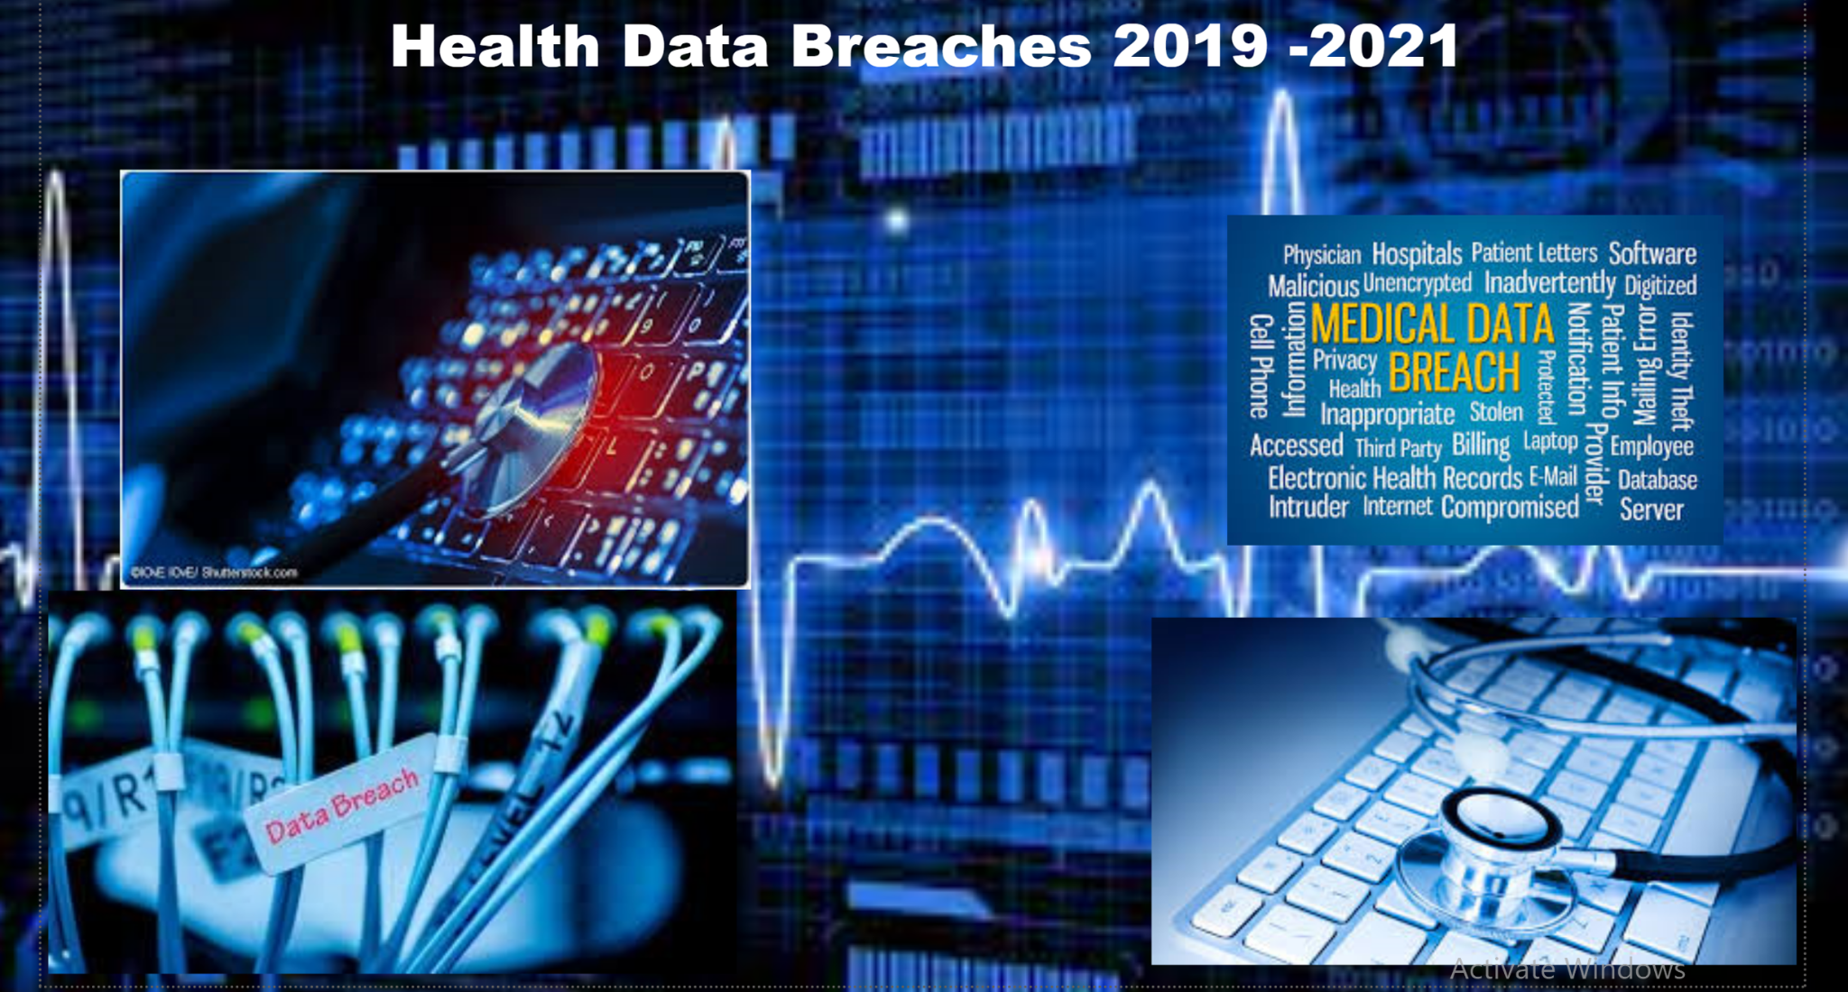

**KPIs**

When selecting a dataset for creating an engaging dashboard, it is essential to ensure that the dataset lends itself to the creation of at least two Key Performance Indicators (KPIs). The chosen topic should also be interesting to capture the audience's attention. KPIs play a crucial role in conveying the narrative of the data. Simply presenting a total or aggregate value is insufficient. To effectively tell the story, it is important to have previous data available for comparison with the current data. This enables the visualization of changes over time, providing valuable insights into the evolving trends and patterns within the dataset. By incorporating historical data and showcasing the change over time, the KPIs become more powerful tools for storytelling and facilitating a deeper understanding of the data.

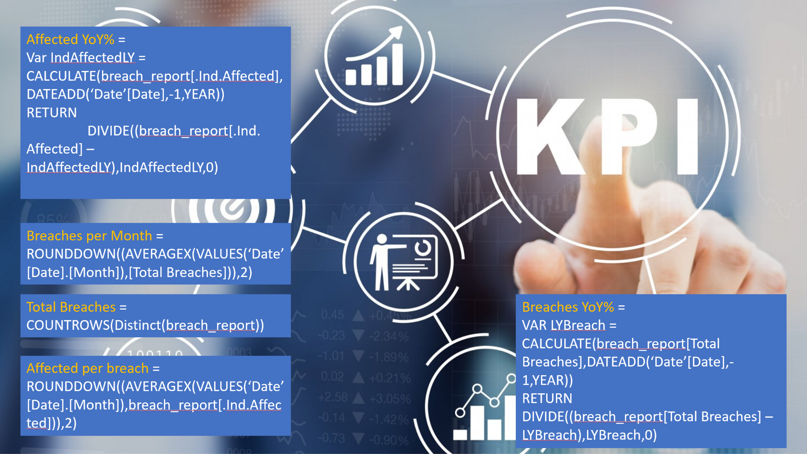

|  |  |
| --- | --- |
| **Affected ColorByIncreaseDecrease** | **VAR currentValue = [Affected YoY%] -- Replace [YourMeasure] with your actual measure name**  **RETURN**  **IF(ISBLANK(currentValue) ,**  **BLANK(),**  **IF(currentValue > 0,**  **"Red", -- Set the color to green if the current value is greater than the previous value**  **IF(currentValue < 0,**  **"Green", -- Set the color to red if the current value is less than the previous value**  **"Black" -- Set a default color if the values are equal**  **)**  **)**  **)** |
| **Affected Per Beach** | **DIVIDE([Total Affected],[Total Breaches])** |
| **Affected Yoy Arrow** | **VAR currentValue = [Affected YoY%] // Replace [YourMeasure] with your actual measure name**  **RETURN**  **IF(ISBLANK(currentValue),**  **".",**  **IF(currentValue > 0,**  **UNICHAR(9650), // Up arrow Unicode character**  **IF(currentValue < 0,**  **UNICHAR(9660), // Down arrow Unicode character**  **"."**  **)**  **)**  **)** |
| **Affected YoY%** | **DIVIDE(([Total Affected]-[Total AffectedLY]),[Total AffectedLY],0)** |
| **Breaches ColorByIncreaseDecrease** | **VAR currentValue = [Breaches YoY%] -- Replace [YourMeasure] with your actual measure name**  **RETURN**  **IF(ISBLANK(currentValue) ,**  **BLANK(),**  **IF(currentValue > 0,**  **"Red", -- Set the color to green if the current value is greater than the previous value**  **IF(currentValue < 0,**  **"Green", -- Set the color to red if the current value is less than the previous value**  **"Black" -- Set a default color if the values are equal**  **)**  **)**  **)** |
| **Breaches Per Month** | **ROUND(AVERAGEX(VALUES('Calendar'[Month]),[Total Breaches]),0)** |
| **Breaches Yoy Arrow** | **VAR currentValue = [Breaches YoY%] // Replace [YourMeasure] with your actual measure name**  **RETURN**  **IF(ISBLANK(currentValue),**  **".",**  **IF(currentValue > 0,**  **UNICHAR(9650), // Up arrow Unicode character**  **IF(currentValue < 0,**  **UNICHAR(9660), // Down arrow Unicode character**  **"."**  **)**  **)**  **)** |
| **Breaches YoY%** | **DIVIDE(([Total Breaches]-[Total BreachesLY]),[Total BreachesLY],0)** |
| **Total Affected** | **SUM('Breach Report 2009-2017'[Individuals Affected])** |
| **Total AffectedLY** | **CALCULATE([Total Affected],DATEADD('Calendar'[Date],-1,YEAR))** |
| **Total Breaches** | **COUNT('Breach Report 2009-2017'[Business Associate Present])** |
| **Total BreachesLY** | **CALCULATE([Total Breaches],DATEADD('Calendar'[Date],-1,YEAR))** |

**Data Dictionary**

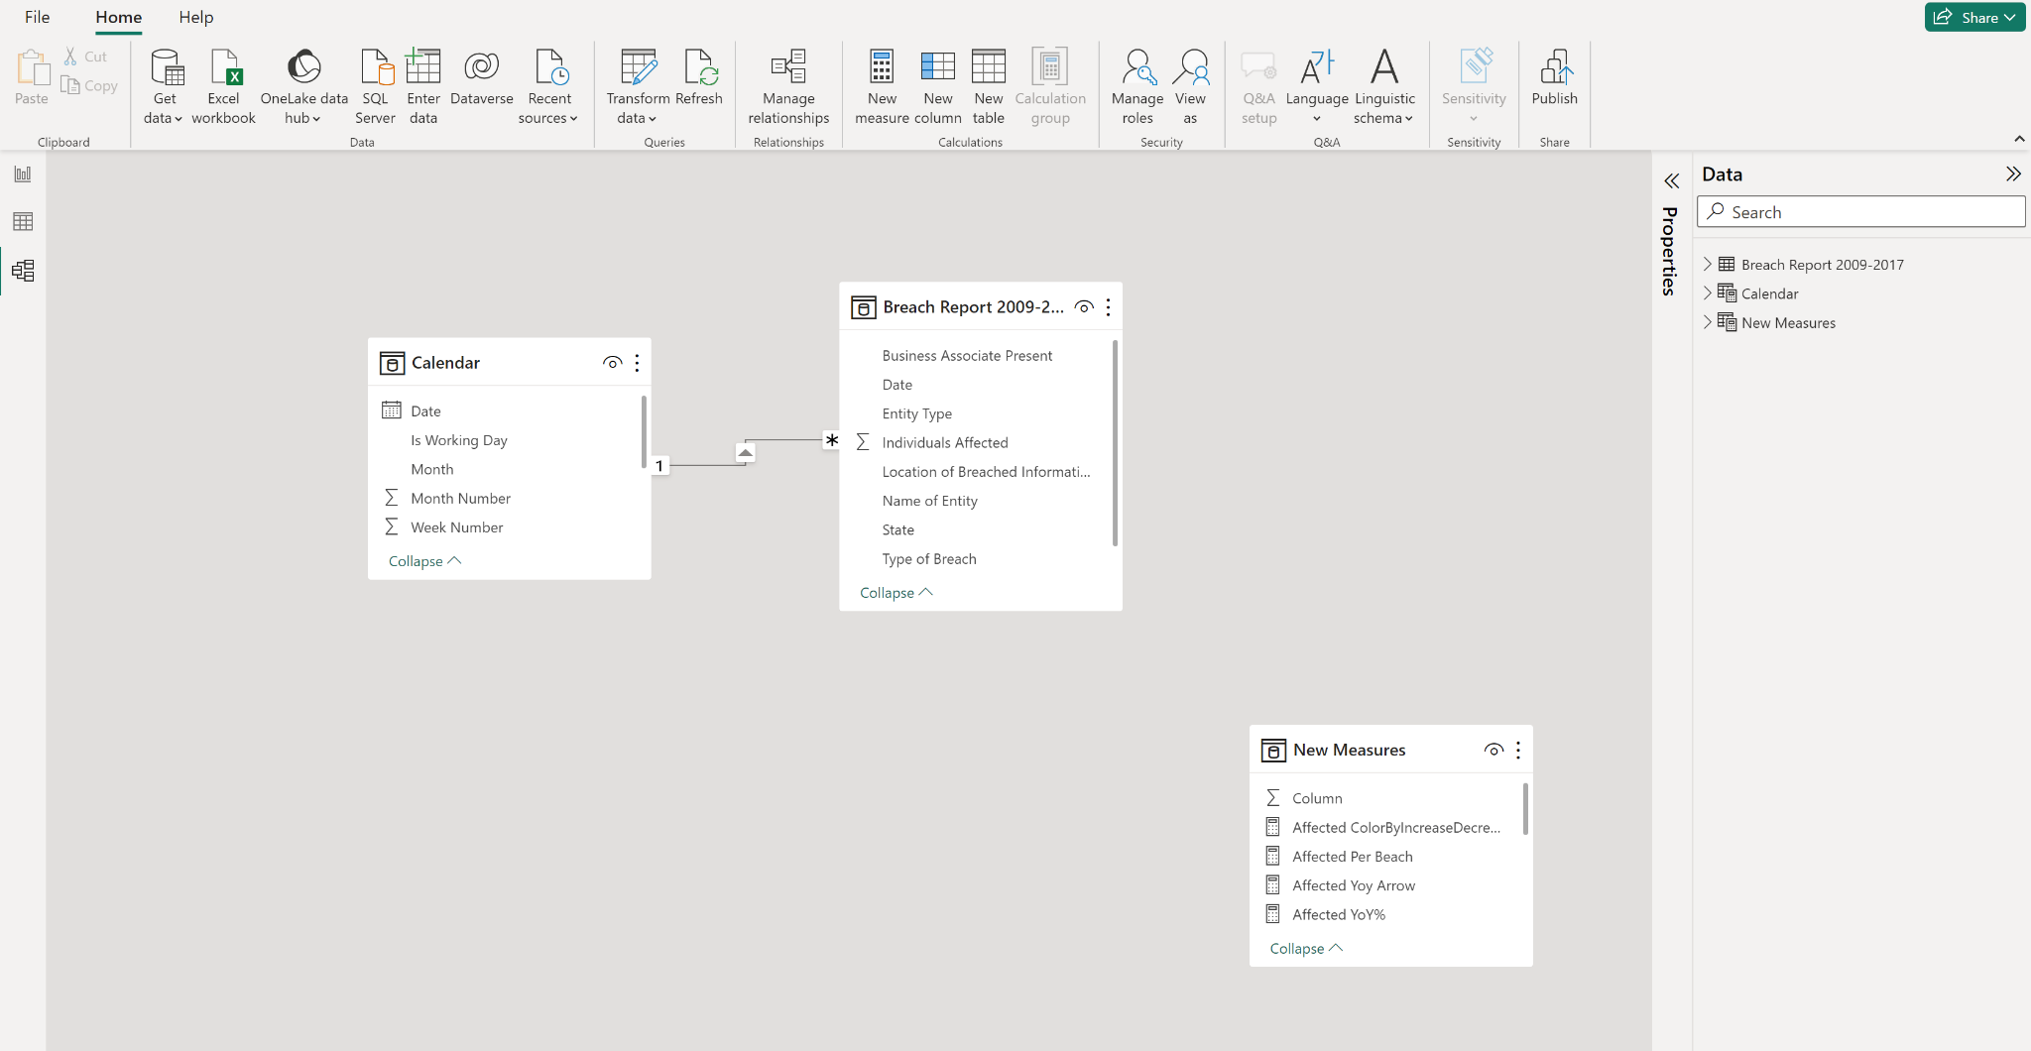

**Executive Summary**

**Encountered Challenges:**

1. Handling CSV File Format: The chosen dataset was in CSV format, causing complications due to commas within the title column. This resulted in title text being mistakenly split into multiple columns. To address this issue, the data had to be transformed to extract values enclosed in quotes while disregarding commas within the quotes.
2. Dealing with Unrecognizable Characters: The "Name of Covered Entity" field contained some unrecognizable characters, which needed to be handled appropriately. To ensure data integrity, any unrecognizable characters, such as the displayed image, were replaced with apostrophes to maintain consistency and readability.
3. Implementing DAX Formulas: Creating the proper DAX formulas posed a challenge, particularly when isolating the total number of incidents involving a business associate. Correct usage of the FILTER command was crucial to obtaining accurate results. Ensuring the formulas were written correctly and yielded the desired outcome required attention to detail.
4. Selecting Suitable Visualizations: Initially, the visual representations included only three visuals, one of which was a pie chart. However, it was realized that pie charts are not ideal for displaying exact values or illustrating changes over time. Given the requirement to showcase year-to-year and monthly changes, stacked column and line graphs were eventually chosen as more appropriate visualizations.
5. Identifying Positive Insights: The data revealed an annual increase in the number of individuals affected and the overall number of breaches. To provide a balanced narrative, it was necessary to delve deeper into the data, examining breach types and their nature to identify potential areas for improvement. Analysis revealed that remote incidents such as hacking consistently increased each year, while breaches resulting from employee errors, such as improper disposal, theft, and unauthorized access, decreased. These findings were incorporated into the messaging, adding a positive perspective to the overall analysis. By addressing these challenges and finding suitable solutions, the project was able to overcome data formatting issues, ensure accurate analysis through proper DAX formulas, choose appropriate visualizations, and highlight positive insights in the messaging.

**Key Insights & Takeaways**

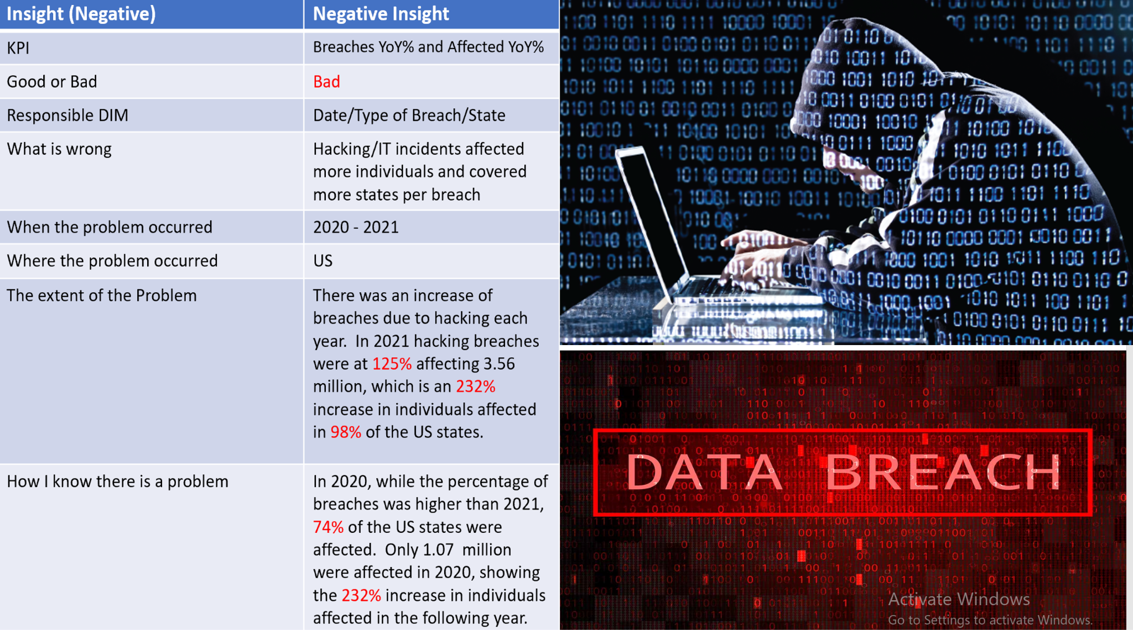

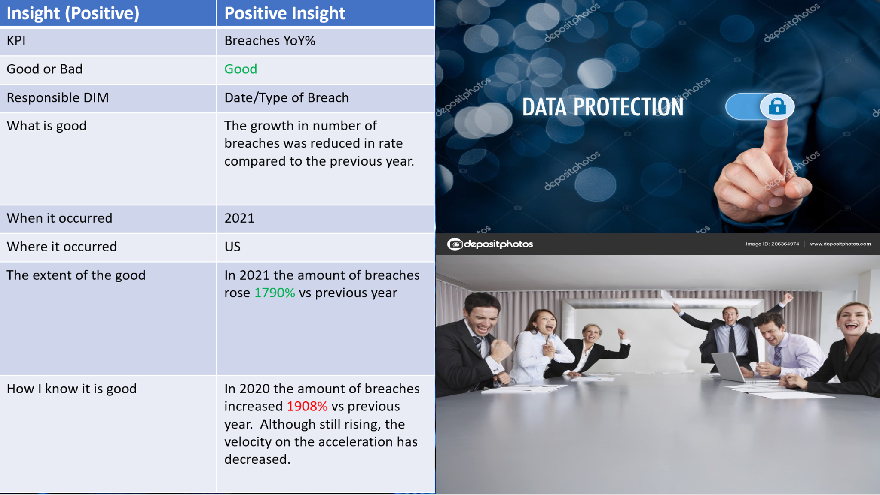

**Suggestions**

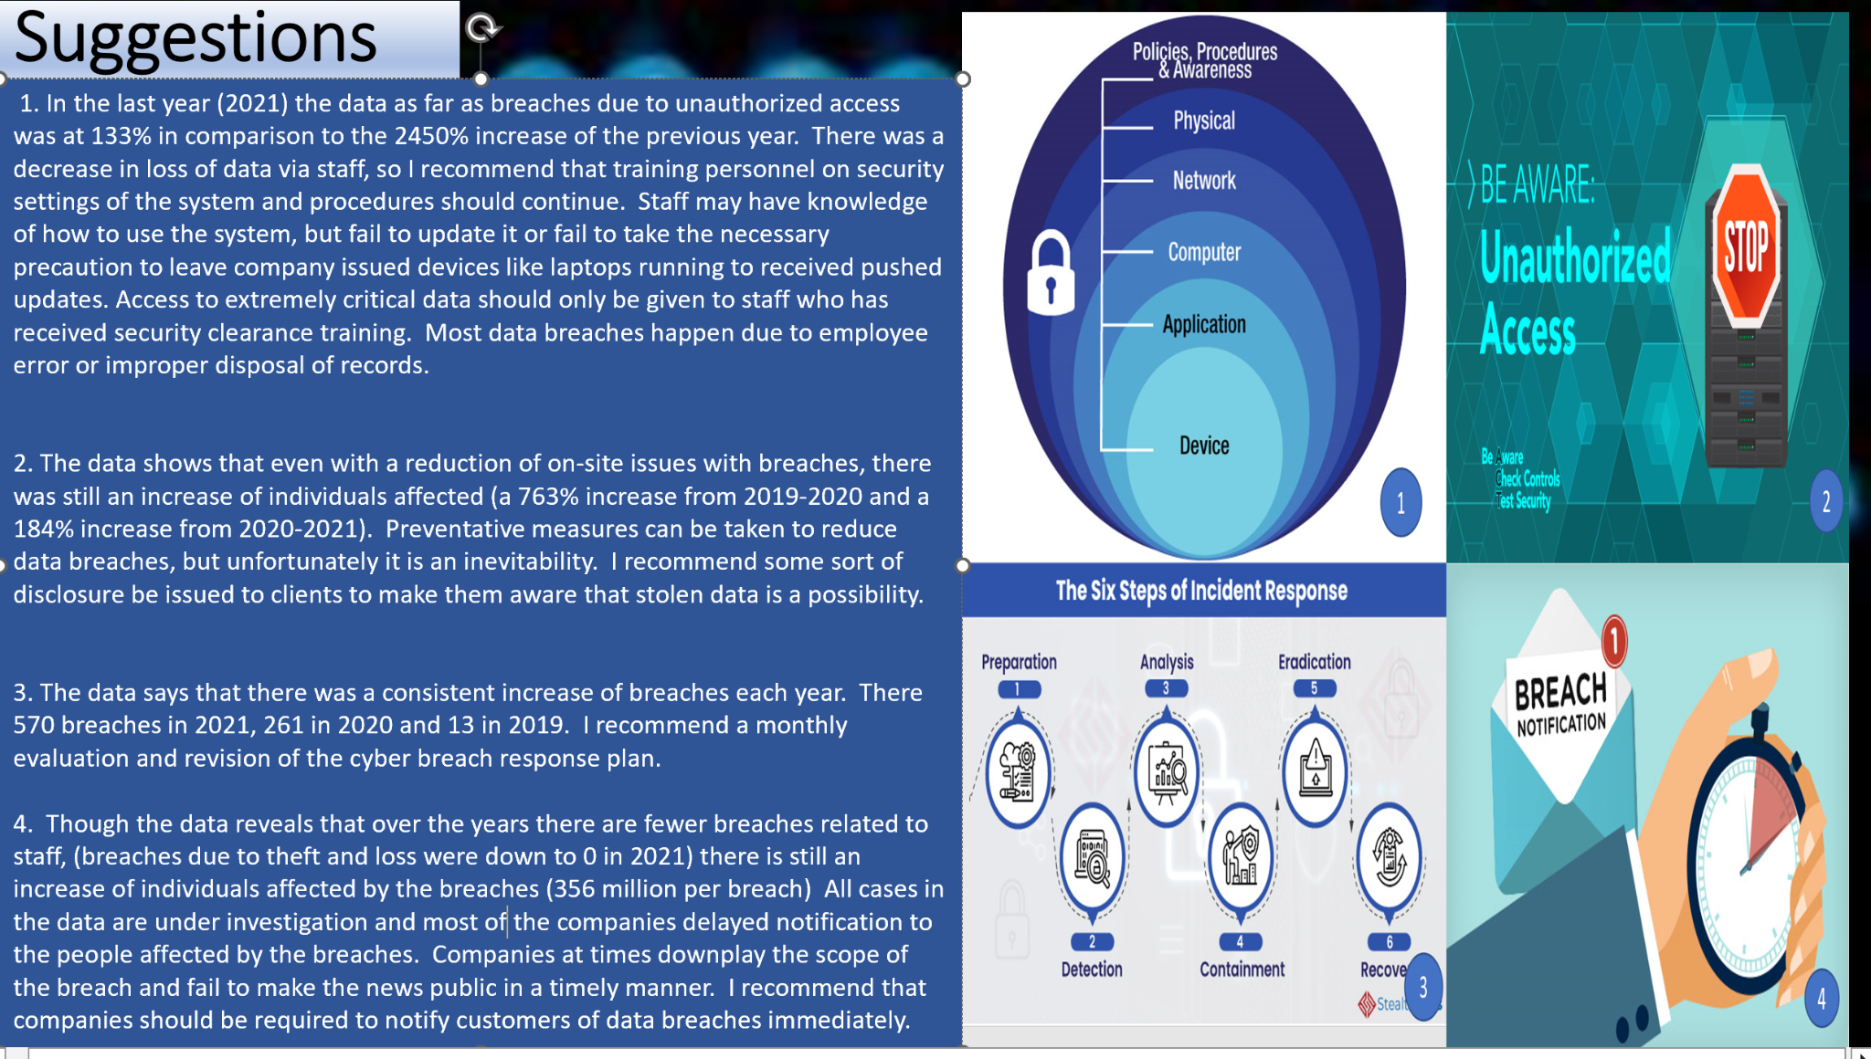

# **Deployment**

